Introducing Cuanto

Cuanto is a test results repository and test results analysis application. Many organizations produce large quantities of automated test results from the regular execution of functional and integrated tests. Cuanto is a tool for storing those test results in logical groups, classifying the nature of individual test failures and providing statistic data about the test results.

Technology
Cuanto is a web application built using Grails. It uses a SQL database to store data. It has a client API that includes an Ant task for submitting test results to the web application. The web application uses ajax-driven sortable data tables for data display and in-table data entry.

Test Results Repository
Cuanto can store results for automated and manual test results. At present it can parse JUnit and TestNG output files.

Projects and Groups
Each logical grouping of tests is a Project and multiple Projects can be logically grouped, for instance you might have projects titled “Functional Tests” and “Integration Tests” that are both part of a “My Cool Application” group. A group view is available to display the most recent test result summary for a group of projects.

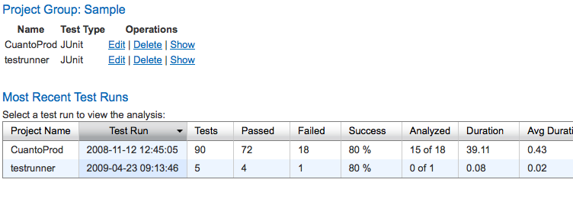

Test Runs
Each execution of a project’s tests is called a Test Run. Cuanto will show the history of test runs for a given project, including data such as the number of tests executed, passed, failed, duration and the number of test failures that have been analyzed. It can also store metadata about each test run like build number, milestone and environment. It displays of graph of a project’s success rate trend over time.

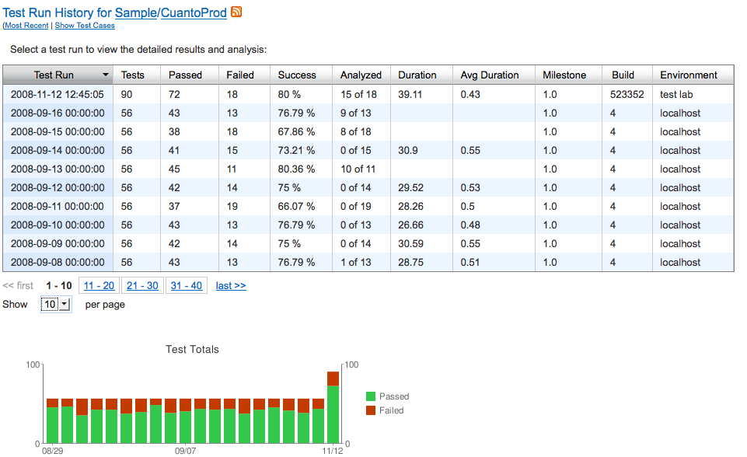

Test Analysis
In the Analysis view, Cuanto allows you to view the failed tests and the output of those tests, and categorize the reason for the test failure (e.g. Bug, Environment, Test Bug, No Repro, etc.). If a bug number is provided it can link to a defined bug system. The current owner of a test failure can be indicated and arbitrary notes can also be entered for a particular test failure.

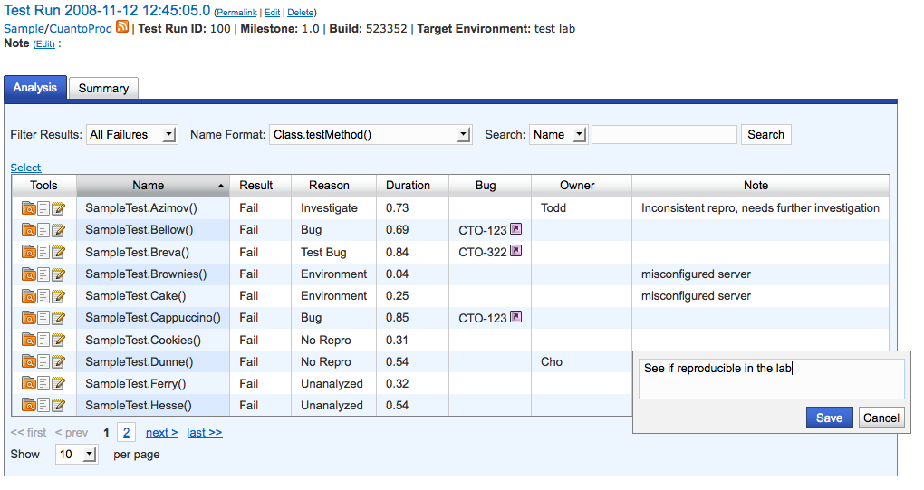

Cuanto supports taking the analysis for a single test result and applying that analysis in bulk to other test results, so it speeds analysis when the same failure condition is responsible for a large number of failures.

Cuanto tracks historical analysis for each test case, so you can easily look at the analysis for past failures of a particular test and optionally apply that analysis to the present test result.

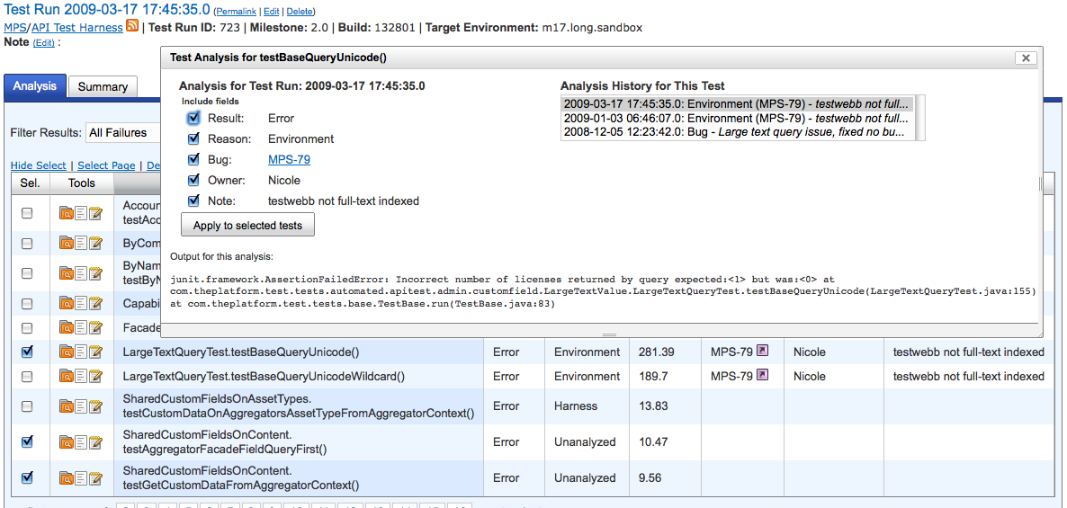

As analysis is entered for a test run, Cuanto keeps statistics about the test run analysis such as the distribution of failure reasons (e.g. 70% Bugs, 30% Environment) and all of the bugs referenced in the analyses and how many failures are associated with each bug.

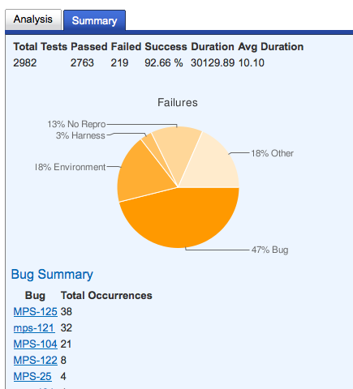

The test analysis view also allows you to sort by different fields (test name, failure reason, duration, bugs, owner, notes) as well as searching different fields such as test name, owner, notes and test output.

The search functionality can be particularly powerful when combined with the bulk analysis functionality. For instance, maybe ReallyBadException caused 25 test failures for a particular test run. You could easily search to narrow the result set down to just the failures that contained ReallyBadException in the test output, then apply the analysis for one of those tests, e.g. Bug 82, to all of the currently selected tests.

What’s Next?
Planned improvements for Cuanto include:
- Additional ease-of-use UI enhancements
- Customizable columns for the analysis table
- User / Role / Permissions model, possible LDAP integration
- Bug system plugins
- Incremental test result submissions (submit results as they occur, rather than once the test run is complete)
- UI for manually uploading test result files
- Parsers for additional test result formats
- Increased test coverage, including Selenium tests

History
The idea for Cuanto came about as a result of the internal needs of thePlatform, Inc., to manage large numbers of test results. The principal developer of Cuanto is Todd Wells, who developed it mostly in his spare time over the course of a year. Cuanto has incubated at thePlatform through a number of internal versions. It is presently used by thePlatform to track test results for over 20 different projects, with over 800 test runs to date with over 230,000 individual stored test results.

License
Cuanto has been made available to the public under the LGPL, version 3.

